EC4070: Data Structures and Algorithms

LAB 04

K.J.M.U.G.S. Eranda Jayasinghe

2021/E/075

SEMESTER 4

EC4070

18.10.2023

FINAL

Q1.

import java.util.PriorityQueue;

public class Max {

public static int maxim(int[] A, int k) {

PriorityQueue<Integer> minHeap = new PriorityQueue<>();

for (int n : A) {

minHeap.offer(n);

}

for (int i = 0; i < k; i++) {

int smallest = minHeap.poll();

minHeap.offer(-smallest);

}

int arraySum = 0;

for (int n : minHeap) {

arraySum += n;

}

return arraySum;

}

public static void main(String[] args) {

int[] A = {4,2,3,12,6,8,10};

int k = 2;

int result = maxim(A, k);

System.out.println("Maximum array sum after " + k + " negations: " + result);

}

}

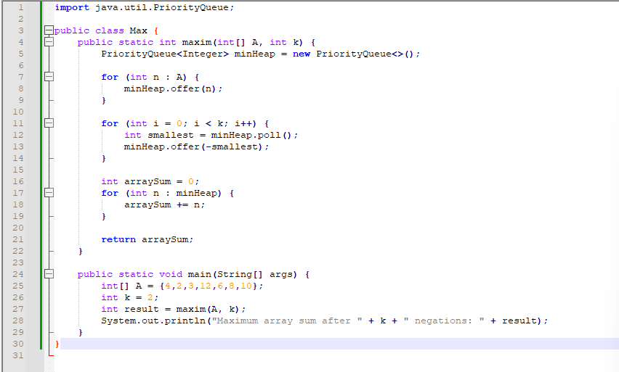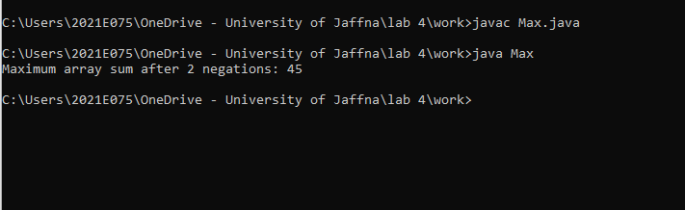

Q2.

import java.util.Scanner;

class Node {

int d;

Node n;

public Node(int d) {

this.d = d;

}

}

class CircularLinkedList {

private Node head;

private int size;

public CircularLinkedList(int n) {

size = n;

if (n < 1) {

return;

}

head = new Node(1);

Node current = head;

for (int i = 2; i <= n; i++) {

current.n = new Node(i);

current = current.n;

}

current.n = head;

}

public void solveJosephusProblem(int m) {

Node current = head;

Node prev = null;

System.out.print("The people who committed suicide: ");

while (size > 1) {

for (int i = 1; i < m; i++) {

prev = current;

current = current.n;

}

prev.n = current.n;

System.out.print(current.d + " ");

current = prev.n;

size--;

}

int josephusPosition = current.d;

System.out.println("\nThe position to be alive: " + josephusPosition);

}

}

public class Joseph{

public static void main(String[] args) {

Scanner x = new Scanner(System.in);

System.out.print("Enter the number of people in the circle (n): ");

int n = x.nextInt();

System.out.print("Enter the number used for counting off (m): ");

int m = x.nextInt();

CircularLinkedList circularList = new CircularLinkedList(n);

circularList.solveJosephusProblem(m);

}

}

